**1. date**

MainActivity.java

package com.example.date;  
  
import androidx.appcompat.app.AppCompatActivity;  
  
import android.os.Bundle;  
import android.view.View;  
import android.widget.Button;  
import android.widget.ImageView;  
import android.widget.TextView;  
  
import java.util.Calendar;  
import java.util.Date;  
  
public class MainActivity extends AppCompatActivity {  
  
 ImageView iv;  
 TextView tv;  
 Button b;  
 @Override  
 protected void onCreate(Bundle savedInstanceState) {  
 super.onCreate(savedInstanceState);  
 setContentView(R.layout.*activity_main*);  
  
 iv=findViewById(R.id.*iv*);  
 tv=findViewById(R.id.*tv*);  
 b=findViewById(R.id.*btn*);  
  
 b.setOnClickListener(new View.OnClickListener() {  
 @Override  
 public void onClick(View v) {  
 Date currentDate= Calendar.*getInstance*().getTime();  
 tv.setText(currentDate.toString());  
 }  
 });  
  
 }  
}

activity_main.xml

<?xml version="1.0" encoding="utf-8"?>  
<androidx.constraintlayout.widget.ConstraintLayout xmlns:android="http://schemas.android.com/apk/res/android"  
 xmlns:app="http://schemas.android.com/apk/res-auto"  
 xmlns:tools="http://schemas.android.com/tools"  
 android:layout_width="match_parent"  
 android:layout_height="match_parent"  
 tools:context=".MainActivity">  
  
 <ImageView  
 android:id="@+id/iv"  
 android:layout_width="239dp"  
 android:layout_height="147dp"  
 android:src="@drawable/clk"  
 app:layout_constraintBottom_toBottomOf="parent"  
 app:layout_constraintEnd_toEndOf="parent"  
 app:layout_constraintStart_toStartOf="parent"  
 app:layout_constraintTop_toTopOf="parent"  
 app:layout_constraintVertical_bias="0.148" />  
  
 <Button  
 android:id="@+id/btn"  
 android:layout_width="wrap_content"  
 android:layout_height="wrap_content"  
 android:text="Get Date"  
 app:layout_constraintBottom_toBottomOf="parent"  
 app:layout_constraintEnd_toEndOf="parent"  
 app:layout_constraintHorizontal_bias="0.498"  
 app:layout_constraintStart_toStartOf="parent"  
 app:layout_constraintTop_toTopOf="parent"  
 app:layout_constraintVertical_bias="0.448" />  
  
 <TextView  
 android:id="@+id/tv"  
 android:layout_width="180dp"  
 android:layout_height="53dp"  
 android:textSize="20sp"  
 app:layout_constraintBottom_toBottomOf="parent"  
 app:layout_constraintEnd_toEndOf="parent"  
 app:layout_constraintHorizontal_bias="0.498"  
 app:layout_constraintStart_toStartOf="parent"  
 app:layout_constraintTop_toTopOf="parent"  
 app:layout_constraintVertical_bias="0.612" />  
</androidx.constraintlayout.widget.ConstraintLayout>

**Output**

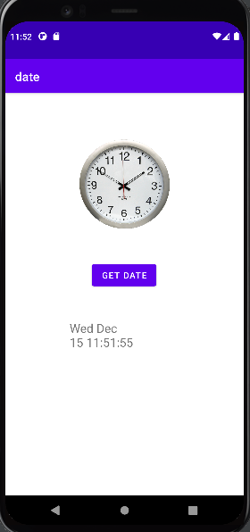

**2. Explicit Intent**

MainActivity.java

package com.example.explicitintent;  
  
import androidx.appcompat.app.ActionBar;  
import androidx.appcompat.app.AppCompatActivity;  
  
import android.content.Intent;  
import android.os.Bundle;  
import android.view.View;  
import android.widget.Button;  
import android.widget.EditText;  
  
public class MainActivity extends AppCompatActivity {  
  
 Button b;  
 EditText n,e,p;  
 @Override  
 protected void onCreate(Bundle savedInstanceState) {  
 super.onCreate(savedInstanceState);  
 setContentView(R.layout.*activity_main*);  
 ActionBar a=getSupportActionBar();  
 a.setTitle("Activity 1");  
 b=findViewById(R.id.*b*);  
 n=findViewById(R.id.*n*);  
 e=findViewById(R.id.*e*);  
 p=findViewById(R.id.*p*);  
 b.setOnClickListener(new View.OnClickListener() {  
 @Override  
 public void onClick(View v) {  
 Intent i=new Intent(MainActivity.this, MainActivity2.class);  
 String user=n.getText().toString();  
 i.putExtra("userName", user);  
 String email=e.getText().toString();  
 i.putExtra("userEmail", email);  
 String phone=p.getText().toString();  
 i.putExtra("userPhone", phone);  
 startActivity(i);  
  
  
 }  
 });  
 }  
}

activity_main.xml

<?xml version="1.0" encoding="utf-8"?>  
<androidx.constraintlayout.widget.ConstraintLayout xmlns:android="http://schemas.android.com/apk/res/android"  
 xmlns:app="http://schemas.android.com/apk/res-auto"  
 xmlns:tools="http://schemas.android.com/tools"  
 android:layout_width="match_parent"  
 android:layout_height="match_parent"  
 tools:context=".MainActivity">  
  
 <Button  
 android:id="@+id/b"  
 android:layout_width="wrap_content"  
 android:layout_height="wrap_content"  
 android:text="Go"  
 app:layout_constraintBottom_toBottomOf="parent"  
 app:layout_constraintEnd_toEndOf="parent"  
 app:layout_constraintHorizontal_bias="0.498"  
 app:layout_constraintStart_toStartOf="parent"  
 app:layout_constraintTop_toTopOf="parent"  
 app:layout_constraintVertical_bias="0.499" />  
  
 <EditText  
 android:id="@+id/n"  
 android:layout_width="wrap_content"  
 android:layout_height="wrap_content"  
 android:ems="10"  
 android:inputType="textPersonName"  
 android:hint="Name"  
 app:layout_constraintBottom_toBottomOf="parent"  
 app:layout_constraintEnd_toEndOf="parent"  
 app:layout_constraintHorizontal_bias="0.557"  
 app:layout_constraintStart_toStartOf="parent"  
 app:layout_constraintTop_toTopOf="parent"  
 app:layout_constraintVertical_bias="0.145" />  
  
 <EditText  
 android:id="@+id/e"  
 android:layout_width="wrap_content"  
 android:layout_height="wrap_content"  
 android:ems="10"  
 android:hint="Email"  
 android:inputType="textEmailAddress"  
 app:layout_constraintBottom_toBottomOf="parent"  
 app:layout_constraintEnd_toEndOf="parent"  
 app:layout_constraintHorizontal_bias="0.557"  
 app:layout_constraintStart_toStartOf="parent"  
 app:layout_constraintTop_toTopOf="parent"  
 app:layout_constraintVertical_bias="0.252" />  
  
 <EditText  
 android:id="@+id/p"  
 android:layout_width="wrap_content"  
 android:layout_height="wrap_content"  
 android:ems="10"  
 android:hint="Phone"  
 android:inputType="phone"  
 app:layout_constraintBottom_toBottomOf="parent"  
 app:layout_constraintEnd_toEndOf="parent"  
 app:layout_constraintHorizontal_bias="0.557"  
 app:layout_constraintStart_toStartOf="parent"  
 app:layout_constraintTop_toTopOf="parent"  
 app:layout_constraintVertical_bias="0.358" />  
  
</androidx.constraintlayout.widget.ConstraintLayout>

MainActivity2.java

package com.example.explicitintent;  
  
import androidx.appcompat.app.ActionBar;  
import androidx.appcompat.app.AppCompatActivity;  
  
import android.content.Intent;  
import android.os.Bundle;  
import android.widget.Button;  
import android.widget.TextView;  
  
public class MainActivity2 extends AppCompatActivity {  
  
  
 @Override  
 protected void onCreate(Bundle savedInstanceState) {  
 super.onCreate(savedInstanceState);  
 setContentView(R.layout.*activity_main2*);  
 ActionBar a=getSupportActionBar();  
 a.setTitle("Activity 2");  
  
 TextView n=findViewById(R.id.*n*);  
 Intent i=getIntent();  
 String name=i.getStringExtra("userName");  
 String email=i.getStringExtra("userEmail");  
 String phone=i.getStringExtra("userPhone");  
 n.setText("Name: "+name+"\nEmail: "+email+"\nPhone: "+phone);  
  
 }  
}

activity_main2.xml

<?xml version="1.0" encoding="utf-8"?>  
<androidx.constraintlayout.widget.ConstraintLayout xmlns:android="http://schemas.android.com/apk/res/android"  
 xmlns:app="http://schemas.android.com/apk/res-auto"  
 xmlns:tools="http://schemas.android.com/tools"  
 android:layout_width="match_parent"  
 android:layout_height="match_parent"  
 tools:context=".MainActivity2">  
  
 <TextView  
 android:id="@+id/n"  
 android:layout_width="257dp"  
 android:layout_height="150dp"  
 android:textStyle="bold"  
 android:textSize="20sp"  
 app:layout_constraintBottom_toBottomOf="parent"  
 app:layout_constraintEnd_toEndOf="parent"  
 app:layout_constraintStart_toStartOf="parent"  
 app:layout_constraintTop_toTopOf="parent"  
 app:layout_constraintVertical_bias="0.353" />  
  
  
</androidx.constraintlayout.widget.ConstraintLayout>

**Output**

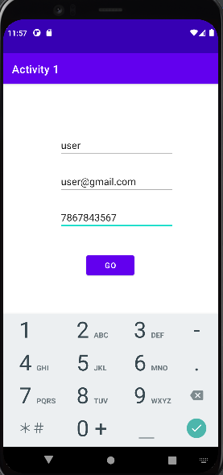 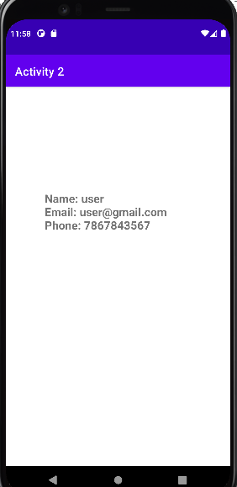

**3. Implicit Intent**

MainActivity.java

package com.example.implicitintent;  
  
import androidx.appcompat.app.ActionBar;  
import androidx.appcompat.app.AppCompatActivity;  
  
import android.content.Intent;  
import android.net.Uri;  
import android.os.Bundle;  
import android.view.View;  
import android.widget.Button;  
  
public class MainActivity extends AppCompatActivity {  
  
 @Override  
 protected void onCreate(Bundle savedInstanceState) {  
 super.onCreate(savedInstanceState);  
 setContentView(R.layout.*activity_main*);  
 ActionBar a=getSupportActionBar();  
 a.setTitle("Implicit Intent");  
 Button b=findViewById(R.id.*b*);  
 b.setOnClickListener(new View.OnClickListener() {  
 @Override  
 public void onClick(View v) {  
 Intent i=new Intent(Intent.*ACTION_VIEW*, Uri.*parse*("https://www.google.com/"));  
 startActivity(i);  
 }  
 });  
  
 }  
}

activity_main.xml

<?xml version="1.0" encoding="utf-8"?>  
<androidx.constraintlayout.widget.ConstraintLayout xmlns:android="http://schemas.android.com/apk/res/android"  
 xmlns:app="http://schemas.android.com/apk/res-auto"  
 xmlns:tools="http://schemas.android.com/tools"  
 android:layout_width="match_parent"  
 android:layout_height="match_parent"  
 tools:context=".MainActivity">  
  
 <Button  
 android:id="@+id/b"  
 android:layout_width="wrap_content"  
 android:layout_height="wrap_content"  
 android:text="Click Me"  
 app:layout_constraintBottom_toBottomOf="parent"  
 app:layout_constraintEnd_toEndOf="parent"  
 app:layout_constraintStart_toStartOf="parent"  
 app:layout_constraintTop_toTopOf="parent" />  
  
</androidx.constraintlayout.widget.ConstraintLayout>

**Output**

